Wheelwright Cluster HOA
September Board Meeting
Sunday, September 28th, 2025 at 7:00 pm

ATTENDEES: Kristina Myer, Kelly Fairbank, Cyndi Hartman, Sandy Mohler, Katie Jay, Aaron Rider.

AGENDA

TREE WORK
- 2252 Ailing oak tree -
- Submitted additional documents for the application to RA on 9/12 - have not heard back about getting on their DRB calendar yet
- Decided on cherry tree for the replacement
- Can we do the replacement trees before the end of this year - cherry at 2252 and blackgum behind 2207?
- Next tree inspection?

EROSION/VCAP PROJECT -
- Adele replied to Sandy’s email on 9/1. Here is her email: https://mail.google.com/mail/u/1/#sent/FMfcgzQbgcXPgWwgSHDHJxztMDjWFLSB
- Next steps – will see if we can get some more details for Adela, # of plants? Etc.
- We are looking at next spring for the project to start.

LANDSCAPING -
- Ernst seeds for the outer mulched area by entrance:
- https://drive.google.com/file/d/131-2CoNy2PXexJuRsA0CW7FY9bbc5cCN/view?usp=sharing
- Recommends cover crop: Oats (Spring) or Grain Rye (Fall), both at 30 pounds/acre.
- 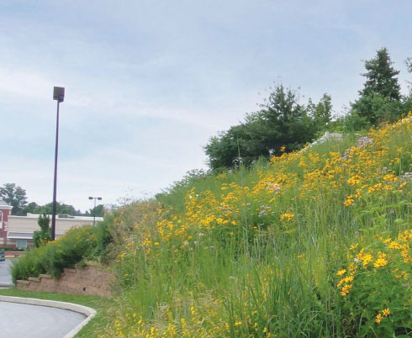
- 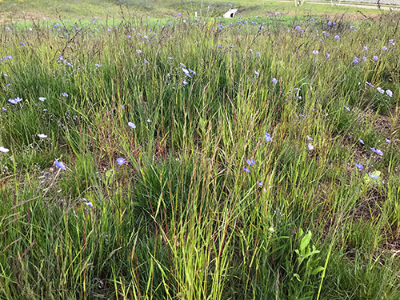
- Or do we want a different look here? Think the amount of shade could cause issues. Maybe ferns. Will look at different options besides just mulch.
- Grass rejuvenation - spoke with Steve at 2242 - he is using a new company this year for his fall grass treatment - Bluesky Landscaping - will update us on how it goes for a potential company to contact for lawn common areas in cluster.

DESIGN UPDATES
- HVAC units -
- Front enclosures - architectural redesign - need to reach out to DRB architect
- Katie and Sandy to work together to update guidelines

CONCRETE
- Spring bids for neighborhood concrete
- Dominion - $11.20/sqft concrete sidewalk
- Brothers - $9.89/sqft concrete sidewalk
- Another quote? We received bids for repaving the cluster from Dulles Asphalt and Concrete (as well as Dominion). Also Manassas Asphalt but they don’t seem to do concrete
- Finley Asphalt & Concrete

CLUSTER CLEAN-UP
- Saturday October 25th at 9:30 am
- Projects:
- Picking up garbage around the cluster, along Olde Crafts up to South Lakes
- Bricks to extend around the garbage can by the tot lot. Maybe extend around the Little Free Library. Looking for other ideas.
- Repainting the speedbumps.
- Secure the edging of the mulch path between the tot lot and Cindy’s house.

2025 YEAR WIND DOWN
- 2026 Proposals needed
- Landscaping - reached out to Chris on 9/17
- Snow removal - reached out to Greg (M & M Expert Services, LLC) on 9/17
- Waiting to hear back from both
- 2026 Budget needed by end of October or early November.
- Annual Meeting (Monday Dec. 1st) topics?
- EV Charging stations - individual and community chargers
- How does the community feel about the board conducting yearly audits of homes in the neighborhood
- Highlight the landscaping of the lower cluster island and front entrance.

ADDITIONAL ITEMS
- Issues with garbage and Recycling pickups – not getting any answer. Not responding to the last couple of emails.
- Cluster Cleanup Set for Oct 25th. Green drop Oct 18th. Hazardous waste Oct 11th
- Pet waste stations - Aaron installed our first pet station by the tot lot! 🎉🎉🎉💩
- Monarch Way Station Sign was installed by Rose.
- Vehicle Registration - done - TM Copy of Updated Homeowner List/Car Registration January 2025
- Online payments – No update
- Car with no plates lower cluster - belongs to 2255 - check in with homeowner end of Jan/beginning of Feb
- Newsletter
- Board member plans for 2026 - Cyndi retiring, Sandy Mohler and Kristinia Myer are up for re-election.

FINANCIALS

NEXT MEETING – Friday, October 24th

